# Website Design Practice Final Exam

## Multiple Choice

*Identify the letter of the choice that best completes the statement or answers the question.*

1. is the current standard language used to create Web pages.

|  |  |
| --- | --- |
| a. | HTML |
| b. | DHTML |
| c. | XHTML |
| d. | XML |

2. You can use the panel to create folders to organize and store the various files for your Web site, and to add pages to your Web site.

|  |  |
| --- | --- |
| a. | Files |
| b. | Application |
| c. | CSS |
| d. | Dreamweaver |

3. The is the large white area in the Dreamweaver program window where you create and edit Web pages.

|  |  |
| --- | --- |
| a. | menu bar |
| b. | document window |
| c. | Insert bar |
| d. | Document toolbar |

4. The includes eight groups of buttons displayed in a drop-down menu.

|  |  |
| --- | --- |
| a. | menu bar |
| b. | document window |
| c. | Insert bar |
| d. | Document toolbar |

5. The left end of the status bar displays the .

|  |  |
| --- | --- |
| a. | Insert bar |
| b. | tag selector |
| c. | Property inspector |
| d. | Multiple Document Interface |

6. The tool is used for panning.

|  |  |
| --- | --- |
| a. | Hand |
| b. | Zoom |
| c. | Select |
| d. | Edit |

7. view shows the page as it would appear in a browser and is primarily used for designing and creating a Web page.

|  |  |
| --- | --- |
| a. | Code and Design |
| b. | Code |
| c. | Debugging |
| d. | Design |

8. view shows the underlying HTML code for the page, but not how it will look on a browser.

|  |  |
| --- | --- |
| a. | Code and Design |
| b. | Code |
| c. | Debugging |
| d. | Design |

9. Most information on a Web page is presented in the form of .

|  |  |
| --- | --- |
| a. | graphics |
| b. | links |
| c. | banners |
| d. | text |

10. are graphics displayed across the top of the screen that can incorporate a company’s logo, contact information, and links to the other pages in the site.

|  |  |
| --- | --- |
| a. | Image maps |
| b. | Links |
| c. | Banners |
| d. | Navigation bars |

11. contain multiple links that are usually organized in rows or columns.

|  |  |
| --- | --- |
| a. | Image maps |
| b. | Forms |
| c. | Banners |
| d. | Navigation bars |

12. The tab of the Help window lists Dreamweaver Help topics by category.

|  |  |
| --- | --- |
| a. | Content |
| b. | Index |
| c. | Search |
| d. | Favorites |

13. a Web site means that you transfer all the files for the site to a Web server.

|  |  |
| --- | --- |
| a. | Pushing |
| b. | Publishing |
| c. | Distributing |
| d. | Finishing |

14. 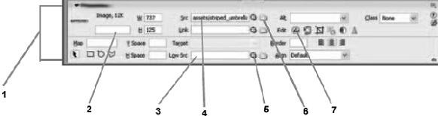

Item 1 above is the .

|  |  |
| --- | --- |
| a. | Tag Inspector |
| b. | Property Inspector |
| c. | Coding toolbar |
| d. | Code view |

 15.

Item above is the Browse for File icon.

|  |  |
| --- | --- |
| a. | 2 |
| b. | 5 |
| c. | 6 |
| d. | 7 |

16. Windows users should save a site map as if they want to insert it on a Web page.

|  |  |
| --- | --- |
| a. | BMP |
| b. | PNG |
| c. | PICT |
| d. | JPG |

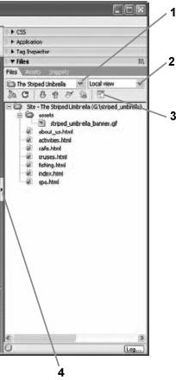

17. Item above can be clicked to hide all panels.

|  |  |
| --- | --- |
| a. | 1 |
| b. | 2 |
| c. | 3 |
| d. | 4 |

18. The content of a Web page contains information used by search engines to help viewers find your Web site.

|  |  |
| --- | --- |
| a. | body |
| b. | html |
| c. | head |
| d. | meta data |

19. is a rating system for Web pages that is similar to rating systems used for movies.

|  |  |
| --- | --- |
| a. | Meta tags |
| b. | MDI |
| c. | PICT |
| d. | PICS |

20. The color is the color that fills the entire Web page.

|  |  |
| --- | --- |
| a. | main |
| b. | fill |
| c. | foreground |
| d. | background |

21. 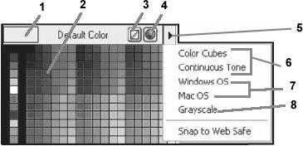

Item(s) in the figure above is/are (a) Web-safe palette(s).

|  |  |
| --- | --- |
| a. | 2 |
| b. | 4 |
| c. | 6 |
| d. | 8 |

 22.

If you don’t like the color you chose, you can click on Item shown in the figure above to switch back to the default color.

|  |  |
| --- | --- |
| a. | 1 |
| b. | 2 |
| c. | 3 |
| d. | 4 |

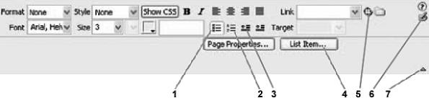 23.

Item in the figure above is the ordered list button.

|  |  |
| --- | --- |
| a. | 1 |
| b. | 2 |
| c. | 3 |
| d. | 4 |

 24.

Item in the figure above is the List item button.

|  |  |
| --- | --- |
| a. | 1 |
| b. | 2 |
| c. | 3 |
| d. | 4 |

 25.

The hexadecimal number system is based on .

|  |  |
| --- | --- |
| a. | 2 |
| b. | 8 |
| c. | 10 |
| d. | 16 |

 26.

Heading is the largest heading format size.

|  |  |
| --- | --- |
| a. | 0 |
| b. | 1 |
| c. | 5 |
| d. | 6 |

27. Which of the following is not a forbidden character for filenames of Web pages?

|  |  |
| --- | --- |
| a. | * |
| b. | & |
| c. | ^ |
| d. | _ |

28. When the paragraph is centered, the HTML code align=“center” is added to the tag.

|  |  |
| --- | --- |
| a. | <pg> |
| b. | <paragraph> |
| c. | <par> |
| d. | <p> |

29. A good rule of thumb is to limit each Web site to no more than font variations.

|  |  |
| --- | --- |
| a. | one |
| b. | two |
| c. | three |
| d. | four |

30. The panel records each editing and formatting task performed and displays them in a list in the order in which they were completed.

|  |  |
| --- | --- |
| a. | Actions |
| b. | History |
| c. | Tasks |
| d. | Task list |

31. A is a line used to separate page elements or to organize information on a page.

|  |  |
| --- | --- |
| a. | line |
| b. | horizontal rule |
| c. | segment |
| d. | stripe |

32. The window size of a maximized browser window in a 640 x 480 monitor is .

|  |  |
| --- | --- |
| a. | 536 x 196 |
| b. | 544 x 378 |
| c. | 600 x 300 |
| d. | 640 x 480 |

33. You can apply numbers, , lowercase letters, or capital letters to an ordered list.

|  |  |
| --- | --- |
| a. | special characters |
| b. | symbols |
| c. | Greek letters |
| d. | Roman numerals |

34. The tags surround each item in a list.

|  |  |
| --- | --- |
| a. | <item></item> |
| b. | <i></i> |
| c. | <li></li> |
| d. | <l></l> |

35. To apply a style, you select the text to which you want to apply the style, then choose a style from the Style list in the .

|  |  |
| --- | --- |
| a. | CSS Styles panel |
| b. | Property inspector |
| c. | Insert bar |
| d. | Layers panel |

36. If you select a style in the CSS Styles panel, the properties are displayed in the .

|  |  |
| --- | --- |
| a. | Properties dialog box |
| b. | Properties panel |
| c. | Properties pane |
| d. | Property inspector |

37. A CSS style consists of two parts: the and the declaration.

|  |  |
| --- | --- |
| a. | description |
| b. | selector |
| c. | header |
| d. | meta tag |

38. When using CSS styles, the Property inspector font sizes are shown in rather than HTML text sizes.

|  |  |
| --- | --- |
| a. | picas |
| b. | points |
| c. | pixels |
| d. | inches |

39. In CSS styles, class names are preceded by a(n) .

|  |  |
| --- | --- |
| a. | period |
| b. | ampersand |
| c. | bang (exclamation mark) |
| d. | asterisk |

40. Though limited in the number of colors they can represent, files have the ability to show transparent areas and are universally recognized by older browsers.

|  |  |
| --- | --- |
| a. | GIF |
| b. | JPEG |
| c. | PNG |
| d. | BMP |

41. files are not universally recognized by older browsers.

|  |  |
| --- | --- |
| a. | GIF |
| b. | JPEG |
| c. | PNG |
| d. | BMP |

42. images often contain many shades of the same color; photographs are often saved in this format.

|  |  |
| --- | --- |
| a. | GIF |
| b. | JPEG |
| c. | PNG |
| d. | BMP |

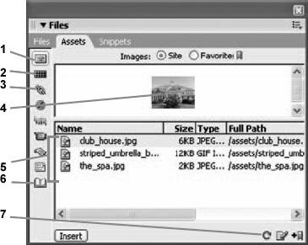 43.

Item in the figure above is the Refresh Site List button.

|  |  |
| --- | --- |
| a. | 1 |
| b. | 3 |
| c. | 6 |
| d. | 7 |

 44.

Item in the figure above is the Images button.

|  |  |
| --- | --- |
| a. | 1 |
| b. | 2 |
| c. | 6 |
| d. | 7 |

45. To delete an asset from the Favorites list, select the asset you want to delete, then press or the Remove from Favorites button on the Assets panel.

|  |  |
| --- | --- |
| a. | [Ctrl][D] |
| b. | [Shift][Ctrl][D] |
| c. | [Delete] |
| d. | [Alt][D] |

46. is descriptive text that appears in place of an image while the image is downloading or when the mouse pointer is placed over it.

|  |  |
| --- | --- |
| a. | Description text |
| b. | Alternate text |
| c. | Tool tip text |
| d. | Keyword text |

47. The use of alternate text is the checkpoint listed in the World Wide Web Consortium (W3C) list of Priority 1 checkpoints.

|  |  |
| --- | --- |
| a. | first |
| b. | second |
| c. | third |
| d. | last |

48. If you choose to use a background image on a Web page, it should be small in file size, and preferably in

format.

|  |  |
| --- | --- |
| a. | JPEG |
| b. | GIF |
| c. | PNG |
| d. | BMP |

49. A(n) is a small graphic that repeats across and down a Web page, appearing as individual squares or rectangles.

|  |  |
| --- | --- |
| a. | background image |
| b. | foreground image |
| c. | tiled image |
| d. | icon |

50. You can use the panel to locate Non-Websafe colors in a Web site.

|  |  |
| --- | --- |
| a. | Assets |
| b. | Files |
| c. | Snippets |
| d. | Colors |

51. In Windows, sometimes it’s necessary to press while you click the Refresh Site List button.

|  |  |
| --- | --- |
| a. | [Ctrl][Shift] |
| b. | [Ctrl] |
| c. | [Shift] |
| d. | [Alt] |

52. To recreate the site cache, you should click on the menu bar, point to Advanced, then click Recreate Site Cache.

|  |  |
| --- | --- |
| a. | File |
| b. | Edit |
| c. | Site |
| d. | Commands |

53. The tags define the beginning and end of the body section of a Web page.

|  |  |
| --- | --- |
| a. | <body></body> |
| b. | <b></b> |
| c. | <body-section></body-section> |
| d. | <main></main> |

54. To rename a file, right-click (Win) or [control]-click (Mac) the file you want to rename, point to , click Rename, then type the new name.

|  |  |
| --- | --- |
| a. | File |
| b. | Edit |
| c. | Modify |
| d. | Site |

55. Creating a table in mode is useful when you want to create a table with a specific number of columns and rows.

|  |  |
| --- | --- |
| a. | Standard |
| b. | Expanded |
| c. | Layout |
| d. | Automatic |

56. In the Table dialog box, the table width, which can be specified in or as a percentage, refers to the width of the table.

|  |  |
| --- | --- |
| a. | picas |
| b. | pixels |
| c. | inches |
| d. | points |

57. With respect to HTML tables, is the distance between the cell content and the cell walls.

|  |  |
| --- | --- |
| a. | cell separation |
| b. | cell spacing |
| c. | cell padding |
| d. | white space |

58. With respect to HTML tables, is the distance between cells.

|  |  |
| --- | --- |
| a. | cell separation |
| b. | cell spacing |
| c. | cell padding |
| d. | white space |

59. In Dreamweaver, you can use mode when you want to draw your own table.

|  |  |
| --- | --- |
| a. | Standard |
| b. | Expanded |
| c. | Layout |
| d. | Automatic |

60. To edit accessibility preferences for a table you should switch to view to edit the code directly.

|  |  |
| --- | --- |
| a. | Design |
| b. | Code |
| c. | Code and Design |
| d. | Table |

61. When working with tables in Expanded mode, you can return to mode by clicking [exit] at the top of the table.

|  |  |
| --- | --- |
| a. | Standard |
| b. | Code |
| c. | Layout |
| d. | Design |

62. You can select a table in Dreamweaver by clicking the table tag on the tag selector.

|  |  |
| --- | --- |
| a. | <t> |
| b. | <table> |
| c. | <tb> |
| d. | <tab> |

63. When working with tables, using the alignment formatting ensures that the table will be centered in all browser windows, regardless of the screen size.

|  |  |
| --- | --- |
| a. | middle |
| b. | regular |
| c. | center |
| d. | justify |

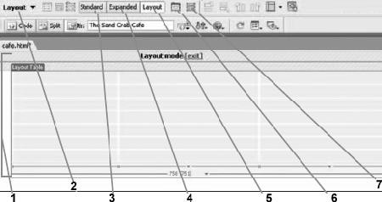 64.

Item in the figure above is the Layout mode button.

|  |  |
| --- | --- |
| a. | 2 |
| b. | 5 |
| c. | 6 |
| d. | 7 |

 65.

Item in the figure above is the Draw Layout Cell button.

|  |  |
| --- | --- |
| a. | 2 |
| b. | 5 |
| c. | 6 |
| d. | 7 |

 66.

Item in the figure above is the Standard mode button.

|  |  |
| --- | --- |
| a. | 1 |
| b. | 2 |
| c. | 3 |
| d. | 4 |

67. In Dreamweaver, to resize a table, row, or column, you must first select the table, then drag one of the table’s

selection handles.

|  |  |
| --- | --- |
| a. | two |
| b. | three |
| c. | four |
| d. | five |

68. To change all the columns in a table so that they are the same size, you should drag the selection handle.

|  |  |
| --- | --- |
| a. | middle-right |
| b. | middle-left |
| c. | top-right |
| d. | bottom-left |

69. To resize an entire table, you should drag the selection handle.

|  |  |
| --- | --- |
| a. | left-corner |
| b. | right-corner |
| c. | top-corner |
| d. | middle-right |

70. You can resize selected columns, rows, or individual cells in a table by entering specific measurements in the W and H text boxes in the .

|  |  |
| --- | --- |
| a. | Table dialog box |
| b. | Insert bar |
| c. | Property inspector |
| d. | Assets panel |

71. The code for two cells that have been merged into one cell that spans two columns is .

|  |  |
| --- | --- |
| a. | <td rowspan=“2”> |
| b. | <tr rowspan=“2”> |
| c. | <td colspan=“2”> |
| d. | <tr colspan=“2”> |

72. The HTML cell tag is .

|  |  |
| --- | --- |
| a. | <c> |
| b. | <cell> |
| c. | <tr> |
| d. | <td> |

73. When entering data in a table, you should press to move the insertion point to the next cell in a row.

|  |  |
| --- | --- |
| a. | [Alt][Tab] |
| b. | [Tab] |
| c. | [Ctrl][Tab] |
| d. | [Shift][Tab] |

74. When entering data in a table, you should press to move the insertion point to the previous cell in a row.

|  |  |
| --- | --- |
| a. | [Alt][Tab] |
| b. | [Tab] |
| c. | [Shift][Tab] |
| d. | [Ctrl][Tab] |

75. To import a delimited file in Dreamweaver, click on the menu bar, point to Import, then click Tabular Data.

|  |  |
| --- | --- |
| a. | Site |
| b. | View |
| c. | Modify |
| d. | File |

76. You can use the Reports command in the Site menu to generate different HTML reports that can help you maintain your Web site.

|  |  |
| --- | --- |
| a. | four |
| b. | five |
| c. | six |
| d. | seven |

77. The Recreate Site Cache command appears under the Advanced submenu of the menu.

|  |  |
| --- | --- |
| a. | File |
| b. | Edit |
| c. | Modify |
| d. | Site |

78. The Check Links Sitewide command appears under the menu.

|  |  |
| --- | --- |
| a. | File |
| b. | Edit |
| c. | Modify |
| d. | Site |

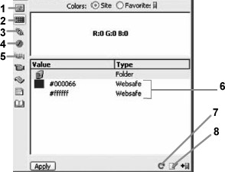 79.

Item in the figure above is the Colors button.

|  |  |
| --- | --- |
| a. | 1 |
| b. | 2 |
| c. | 4 |
| d. | 5 |

80. To open the Reports dialog box, you should click Reports in the menu.

|  |  |
| --- | --- |
| a. | File |
| b. | Edit |
| c. | View |
| d. | Site |

81. To create a(n) link in Dreamweaver, you first select the text or object that you want to serve as a link, then you type the absolute path to the destination Web page in the Link text box in the Property inspector.

|  |  |
| --- | --- |
| a. | external |
| b. | internal |
| c. | embedded |
| d. | hard |

82. A(n) path is a path used for external links that includes the complete address for the destination page, including the protocol (such as http://) and the complete URL.

|  |  |
| --- | --- |
| a. | root-relative |
| b. | external |
| c. | relative |
| d. | absolute |

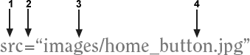 83.

Item in the figure above is the filename of the path.

|  |  |
| --- | --- |
| a. | 1 |
| b. | 2 |
| c. | 3 |
| d. | 4 |

 84.

Item in the figure above is the folder name of the path.

|  |  |
| --- | --- |
| a. | 1 |
| b. | 2 |
| c. | 3 |
| d. | 4 |

85. You should design the navigation structure of your Web site so that viewers are never more than clicks away from the page they are seeking.

|  |  |
| --- | --- |
| a. | one or two |
| b. | two or three |
| c. | three or four |
| d. | four or five |

86. is an example of a root-relative path.

|  |  |
| --- | --- |
| a. | <http://www.yahoo.com/recreation> |
| b. | assets/heroin.gif |
| c. | /striped_umbrella/activities.html |
| d. | spa.html |

87. is an example of an absolute path.

|  |  |
| --- | --- |
| a. | <http://www.yahoo.com/recreation> |
| b. | assets/heroin.gif |
| c. | /striped_umbrella/activities.html |
| d. | spa.html |

88. To recreate the site cache, you can click on the menu bar, click Advanced, then click Recreate Site Cache.

|  |  |
| --- | --- |
| a. | View |
| b. | Site |
| c. | File |
| d. | Edit |

89. A is a specific location on a Web page that has a descriptive name.

|  |  |
| --- | --- |
| a. | link |
| b. | named anchor |
| c. | reference |
| d. | meta tag |

90. In Dreamweaver, named anchors are represented by anchor icons on the Web page.

|  |  |
| --- | --- |
| a. | red |
| b. | green |
| c. | blue |
| d. | yellow |

91. You can show or hide named anchor icons by clicking on the menu bar, pointing to Visual Aids, then clicking Invisible Elements.

|  |  |
| --- | --- |
| a. | View |
| b. | Site |
| c. | File |
| d. | Edit |

92. To insert Flash text on a Web page using Dreamweaver, you choose Common from the , click the Media list arrow, then click Flash Text.

|  |  |
| --- | --- |
| a. | Property inspector |
| b. | File panel |
| c. | Insert bar |
| d. | Site menu |

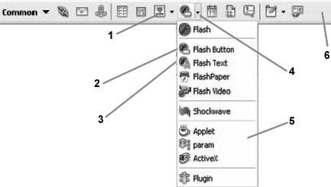 93.

Item in the figure above is the Media list arrow.

|  |  |
| --- | --- |
| a. | 1 |
| b. | 2 |
| c. | 3 |
| d. | 4 |

 94.

Item in the figure above is the Insert bar.

|  |  |
| --- | --- |
| a. | 1 |
| b. | 4 |
| c. | 5 |
| d. | 6 |

95. When inserting Flash Text, the Target should be set to to display the destination page in the parent frameset (replaces the frameset).

|  |  |
| --- | --- |
| a. | _blank |
| b. | _parent |
| c. | _self |

|  |  |
| --- | --- |
| d. | _top |

96. When inserting Flash Text, the Target should be set to to display the destination page in a separate browser window.

|  |  |
| --- | --- |
| a. | _blank |
| b. | _parent |
| c. | _self |
| d. | _top |

97. A navigation bar element has a(n) state when you click the element and continue pressing and holding the mouse button.

|  |  |
| --- | --- |
| a. | Up image |
| b. | Over image |
| c. | Down image |
| d. | Over while down image |

98. A navigation bar element has a(n) state when you click the element.

|  |  |
| --- | --- |
| a. | Up image |
| b. | Over image |
| c. | Down image |
| d. | Over while down image |

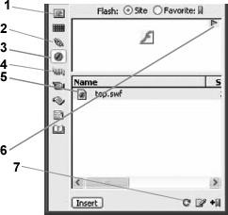 99.

Item in the figure above is the Flash button.

|  |  |
| --- | --- |
| a. | 1 |
| b. | 2 |
| c. | 3 |
| d. | 4 |

 100.

The figure above shows the panel.

|  |  |
| --- | --- |
| a. | Assets |
| b. | Files |
| c. | Snippets |
| d. | Images |

 101.

Item in the figure above is a Flash text file.

|  |  |
| --- | --- |
| a. | 3 |
| b. | 5 |
| c. | 6 |
| d. | 7 |

 102.

Item in the figure above is the URL button.

|  |  |
| --- | --- |
| a. | 1 |
| b. | 2 |
| c. | 3 |
| d. | 4 |

103. In order to view Flash animations, you must have the installed on your computer.

|  |  |
| --- | --- |
| a. | Shockwave player |
| b. | Flash player |
| c. | RealPlayer |
| d. | Fireworks plug-in |

104. To view named anchors when working in Dreamweaver you should make sure that Invisible Elements are being displayed ( --> Visual Aids --> Invisible Elements).

|  |  |
| --- | --- |
| a. | File |
| b. | Edit |
| c. | Site |
| d. | View |

105. The tool is used for magnifying.

|  |  |
| --- | --- |
| a. | Hand |
| b. | Zoom |
| c. | Select |
| d. | Edit |

106. The Layers panel icon used to show that a layer is locked is a .

|  |  |
| --- | --- |
| a. | plus sign |
| b. | check mark |
| c. | padlock |
| d. | minus sign |

107. To increase the size of a stroke, you would increase its .

|  |  |
| --- | --- |
| a. | tip |
| b. | edge |
| c. | fill category |
| d. | texture |

108. The New Document dialog box allows you to choose the color.

|  |  |
| --- | --- |
| a. | pointer |
| b. | canvas |
| c. | ruler |
| d. | text |

109. The arrow keys move an object in 1- increments.

|  |  |
| --- | --- |
| a. | hexadecimal |
| b. | centimeter |
| c. | pixel |
| d. | pica |

110. When a bitmap graphic is enlarged, it may appear .

|  |  |
| --- | --- |
| a. | faded out |
| b. | anti-aliased |
| c. | auto-sized |
| d. | jagged |

111. Auto-sizing .

|  |  |
| --- | --- |
| a. | expands the font size to accommodate the text box size |
| b. | expands the text box size to accommodate the text you enter |
| c. | automatically applies the last selected font size to new text |
| d. | stretches text horizontally |

112. The Tools panel is organized into tool .

|  |  |
| --- | --- |
| a. | groups |
| b. | layers |
| c. | paths |
| d. | anchors |

113. You can modify selected objects and set tool properties and other options using the .

|  |  |
| --- | --- |
| a. | Optimize panel |
| b. | Layers panel |
| c. | 2-Up button |
| d. | Property inspector |

114. Fireworks files are known as .

|  |  |
| --- | --- |
| a. | objects |
| b. | documents |
| c. | layers |
| d. | graphics |

115. The files you create in Macromedia Fireworks have a(n) extension.

|  |  |
| --- | --- |
| a. | .png |
| b. | .eps |
| c. | .jpg |
| d. | .gif |

116. refers to the number of pixels in an image.

|  |  |
| --- | --- |
| a. | Kerning |
| b. | Resolution |
| c. | Aliasing |
| d. | Path |

117. Ruler units are always in .

|  |  |
| --- | --- |
| a. | pixels |
| b. | centimeters |
| c. | millimeters |
| d. | picas |

118. Auto Shapes are complex shapes.

|  |  |
| --- | --- |
| a. | bitmap |
| b. | control |
| c. | layer |
| d. | vector |

119. Indent and alignment are examples of attributes.

|  |  |
| --- | --- |
| a. | canvas |
| b. | vector |
| c. | bitmap |
| d. | text |

120. You can manipulate text by creating a , and then attaching text to it.

|  |  |
| --- | --- |
| a. | path |
| b. | control point |
| c. | stroke |
| d. | fill |